
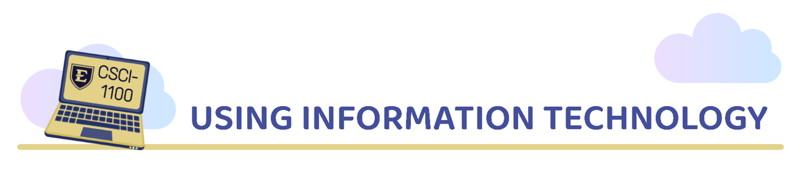

CSCI 1100/1150: Online Asynchronous Course Syllabus

Semester: Summer Session 1 ▪ Year: 2025 ▪ Sections: 901

We, the Using Information Technology leadership, reserve the right to change this syllabus and/or course at any time for any reason.
Welcome to Using Information Technology! Please carefully review this document.

Course Information

Course Description
Navigate the digital age confidently and creatively in our course, designed to arm you with essential tech skills to make you an informed and enlightened digital citizen. By the end, you'll know how to participate safely and ethically online, evaluate information sources, create tech solutions for real-world problems, and communicate effectively about digital technologies. Dive into Digital Literacy, Programming, Data Literacy, Cyber Security, AI and more, to boost productivity and innovation. This course offers a concise yet thorough exploration of today's digital landscape, preparing you for a future where technology is in constant evolution.

Learning Outcomes
- Engage securely and responsibly in digital communities, demonstrating an understanding of digital citizenship principles, including ethical behavior, digital rights, privacy, and online safety, along with the ability to navigate and contribute to the digital world ethically and effectively.
- Assess information sources critically for credibility, ethical use, and security risks, using data literacy skills to make informed decisions.
- Design and implement a technology-based solution to solve a real-world problem using appropriate computing principles and other relevant disciplines.
- Communicate effectively on general topics related to computing technology and the digital landscape.
- Apply modern software tools and platforms to streamline workflows, enhance collaboration, and drive innovation in digital solutions.
- Explore and use Artificial Intelligence and other Emerging Technologies to enhance productivity.

Major Topics
- Digital Literacy  - Tech Product Literacy  - Introduction to Programming  - The Connected World (Networking)  - Web Literacy  - Data Literacy  - Digital Content Creation and Usage  - AI and Machine Learning  - Cyber Security and Privacy  - Digital Citizenship |  Email Correspondence  - ALL email correspondence related to CSCI 1100/1150 should be sent to csci1100@etsu.edu. (questions, comments, feedback, etc.)  - Please refrain from emailing the instructors and graduate assistants directly.  - Provide your lecture or lab section number (901)  - Subject example: CSCI-1150-901 - Data lab question

Corequisites or Prerequisites
None.

Class Meetings
See schedule in Appendix (i). The Department of Computing offers many different times and modalities for CSCI 1100. Additionally, CSCI 1150 is the lab component of CSCI 1100. Both CSCI 1100 and CSCI 1150 must be taken together.

Instructors
Mr. Ryan Haas | Assistant Director of Using Information Technology & Lecturer  College of Business and Technology

Course Materials

Textbooks and Readings
There are no required textbooks for this course. If a textbook is required, we will use free, open-source collaborations to reduce the burden on students. Materials will be provided throughout the semester through D2L.

Technology Resources
For students on main campus, the department's computer labs have all the hardware and software needed to complete this course successfully. If you need to work on your personal computer, however, please install the necessary applications; they are available for Microsoft Windows and macOS computers. You will also need consistent and reliable access to the Internet.
Other software may be used to support topics. All software will be free and widely available. The software will help with the major topics, giving hands-on tools to complement understanding of each topic.

Microsoft 365/Office Software Requirement
- Microsoft 365 (formerly Office) is required to complete some labs and may be used throughout the class for writing reflections, processing data, or presenting findings.
  - The online and mobile app versions of Microsoft Excel, PowerPoint, and Word may not be compatible with some lab activities. Additionally, the versions provided through the App Store on macOS computers may differ from the Office version available for installation through your student account.
  - Installing MS 365 apps using your student license: Visit office.com à Login with your ETSU credentials à If met with a Copilot screen, click “Apps” à On the resulting screen, there is an “Install apps” dropdown button in the top right corner. Select “Microsoft 365 apps”.
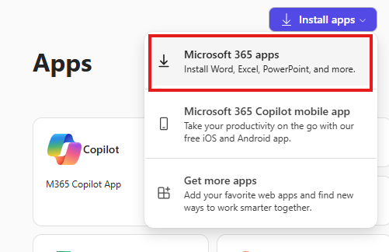
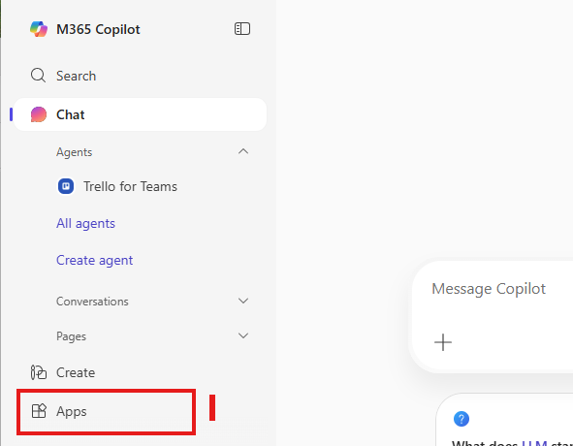

Microsoft 365 IT Assistance & Tips
Contact the ITS Help Desk for assistance with your ETSU Microsoft account and managing installations.
Common error w/ Microsoft logins | If you use another Microsoft account in your web browser, Microsoft’s cookies tend to automatically log you into it! This can be frustrating if you’re trying to log into your student account.  - If you don’t use one account often, consider clearing your browser’s cookies and cache. This will force a fresh login page. Log into the account you plan to use frequently. Whenever you need to log into your other Microsoft account, just open a private or incognito browser Window. When you close this window, the associated browser cookies are cleared, preventing interference with your other Microsoft account.  - If you have two Microsoft accounts that you access frequently (e.g., your work and school account), consider keeping using one web browser (e.g. Firefox) for one account, and another (e.g., Chrome) for the other account.
A pre-existing version of Microsoft Office is already installed | - If you have a pre-installed desktop version of Microsoft 365 that you have already licensed (e.g., such as a home or business license), you may simply keep using that version. Note, however, that while you have an active student status at ETSU, you have access to a student-licensed version should your license expire!  - If you have a new computer and have not purchased an Office license, it is best practice to uninstall Microsoft 365 before attempting to install the version provided through your student account. The ITS Help Desk can assist you!

Course Expectations

Expectations from the Instructor
- Share pre-recorded lectures or lesson content in a timely manner.
- Be attentive to students and their questions.
- Be available to answer questions and provide help related to the course.
- Make a genuine effort to help students achieve course objectives.
- Devote considerable time and effort to the course.

Expectations from Students
- Regularly check and use the D2L course sites for CSCI 1100 and CSCI 1150.
- Be attentive and participate in class activities.
- Complete assignments on time.
- Meet the course objectives sincerely.
- Devote considerable time and effort to the course, including spending 2-3 hours outside class for every hour in class.

Encouraged Student Behaviors
- Ask appropriate questions when unclear about course content.
- Participate actively in class discussions and activities.
- Understand that peers can also be a source of learning alongside the instructor.

Course Format and Evaluation Policies

Course Format
CSCI 1100 should be paired with CSCI 1150. Students will take CSCI 1100 and CSCI 1150 in the same semester in which CSCI 1100 will be the lecture portion of the course, and CSCI 1150 will be the lab portion of the course.
CSCI 1100 Lecture Delivery | CSCI 1150 Lab Delivery
On-Site Lecture Delivery – This modality requires that the students and instructors attend the class meetings in person in an on-campus location. Offered in Fall. | On-Site Lab Delivery – This modality requires that the students and their lab facilitators to attend the lab meetings in person in an on-campus location.
Synchronous Online Lecture Delivery – This modality requires that the students and instructors attend the class meetings virtually at a specificized time. The course materials are delivered live via the Zoom platform. Offered in Fall.
Asynchronous Online Lecture Delivery – This modality does NOT require the students and instructors to attend class at a prescribed time. Instead, the course materials are delivered via the D2L Brightspace learning management system via prerecorded lecture videos, interactive activities, and a variety of other media. | Asynchronous Online Lab Delivery – This modality does NOT require the students and instructors to attend class at a prescribed time. Instead, the lab materials are delivered via the D2L Brightspace learning management system via lab instruction documents and other supplemental links and media.
Course materials and assignments will be available through the course website: https://elearn.etsu.edu.You should check this site daily for updates and announcements. A tentative course schedule is provided separately in D2L and may change throughout the semester to allow extra time for concepts or accommodation for university scheduling.

Evaluation Policies

Personal Learning Labs (10 per semester)
Personal learning labs aren't just any assignments; they're unique assignments customized to match what you're studying and what sparks your curiosity. Whether you're diving into how to protect online privacy, creating your own website, understanding the magic behind AI, or exploring how computers talk to each other across the globe, these labs are here to make learning these complex topics easier and more fun. Personal learning labs offer you choices that help you become a pro in navigating the digital world, no matter what your major is. It's all about giving you the tools and space to explore, create, and learn in a way that's tailored just for you.
Each week, you will work on a personal learning lab that corresponds to the previous week’s lecture topic (see course schedule). In working on lab exercises, you can consult your course materials, discuss with a classmate, talk to your instructor/graduate assistant, use the Center for Academic Achievement, or get assistance, however, the end result must reflect your own effort. You should complete all assignments individually and without generative AI unless otherwise specified.
If assistance is received to complete the assignment, credit must be attributed on the deliverable in the following format:
Resource: <Person’s name, position> or <Website link>
Assistance Received: < A statement of the assistance you received.>
Individual Contribution: <What you, as the individual completing the assignment, did with the help received to ensure the integrity of the work submitted>

Weekly lab work should be completed by the common weekly deadline for Lab, Quiz, and Exit Ticket assignments (Sundays, 11:59 EDT)!

Quizzes
Weekly quizzes will cover topics we discuss in our weekly lesson materials (e.g., videos, lesson slide sets, or notes). You will be allowed two attempts per quiz (some questions will change) to help you master the material. If you use both attempts, your quiz grade will be the higher of your two attempts.
Quizzes will be given on D2L, consisting of multiple-choice, true/false, fill-in-the-blank, and matching questions. Quizzes should be completed by the common weekly deadline for Lab, Quiz, and Exit Ticket assignments (Sundays, 11:59 PM EDT).

Exit Tickets
An Exit Ticket is used to summarize or assess the learning and understanding you have AFTER you have reviewed the weekly lesson materials (e.g., videos, slide sets, or notes) and to gauge whether you enjoyed the material.
Your feedback helps the instructors and lab facilitators gauge how well the class understood the material and lets you reflect on your learning to ensure you are on the right track!
Your Exit Ticket will be found at the bottom of your modules in your CSCI-1100-901 D2L site. It should be completed by the common weekly deadline for Lab, Quiz, and Exit Ticket assignments (Sundays, 11:59 PM EDT).
* Please wait for us to share each topic’s lesson materials before attempting Quizzes and Exit Tickets so you can review them in preparation.

Digital Citizenship Audit
Your Digital Citizenship Audit (DCA) will be a culmination of the various literacies you’ve acquired or grown throughout the semester. The project requires you to perform a comprehensive digital citizenship audit on yourself, allowing you to reflect on your ability to participate fully in your communities and to make smart choices online and offline.
The goal is to reflect on and assess your own digital behaviors, practices, and presence using the literacy competencies you’ve acquired throughout the course. This audit will help you gauge your ability to act as enlightened digital citizens and identify areas for improvement.

DCA Format and Delivery
This assignment's format and delivery can be in any format: written work, a graphical representation, a video presentation, or any other format that you prefer. We require no minimum length, but it is expected that the submissions be thoughtful and thorough.
The following areas should be represented in your audit:
Overview: Demonstrate your competence in six digital citizenship literacy areas through practical application and critical reflection.
Key Literacy Areas:
- Digital Literacy: Evaluating online information credibility
- Data Literacy: Analyzing and visualizing data using Excel
- Web Literacy: Understanding website accessibility principles
- AI Literacy: Critically engaging with AI tools or concepts
- Cybersecurity Literacy: Implementing security practices
- Microsoft Office Proficiency: Using Word, Excel, and PowerPoint effectively
Part A: Skills Application
- Digital Literacy: Perform and document a credibility check on an online article
- Data Literacy: Analyze a dataset in Excel and create at least one visualization
- Web Literacy: Identify 3 website accessibility characteristics and evaluate a website
- AI Literacy: Either use an AI tool and evaluate its output OR write a 2-4 paragraph argument about AI restrictions with citation
- Cybersecurity: Identify one practice/tool to improve security in each domain: Devices, Accounts, and Identity
- Office Skills:
  - Word: Create a formatted report with table of contents, heading styles, and citations
  - Excel: Demonstrated through data literacy component
  - PowerPoint: Design a short presentation with visual aids and animations
Part B: Critical Reflection Reflect on your digital citizenship skills by addressing:
- Strengths: Areas where you excel with specific examples
- Growth areas: Skills needing improvement
- Future goals: Steps to address growth areas (short and long-term)
Format: Creative presentation of your choice that addresses all requirements
The Cumulative Experience Project cannot be made up or submitted late.

Final Grade
The final grade in the course is based on the following breakdown:
Item | Fraction of Overall Grade
Personal Learning Labs | 1/6
Quizzes | 1/6
Exit Tickets | 1/6
Digital Citizenship Audit | 1/2
Note: The DCA is your final project at the end of the semester. Prior to its completion, your overall grade will be calculated as 1/3 Labs + 1/3 Quizzes + 1/3 Exit Tickets.
The course will use the following grading distribution:
Letter Grade | Percentage Range
A+ | 97% - 100%
A | 93% - 96.99%
A- | 90% - 92.99%
B+ | 87% - 89.99%
B | 83% - 86.99%
B- | 80% - 82.99%
C+ | 77% - 79.99%
C | 73% - 76.99%
C- | 70% - 72.99%
D+ | 67% - 69.99%
D | 63% - 66.99%
D- | 60% - 62.99%
F | 0% - 59.99%
Please check your grade often to ensure that you are on track for successful course completion.

Course Policies

Participation
While participation is not directly part of your final grade in this course, you should regularly access your CSCI 1100 and CSCI 1150 D2L sites, engage with the materials provided to you, and complete assignments. To ensure your success in this course, we recommend the following participation strategies:
- Ask questions, be curious, be positive, be supportive.
- Access each piece of content in the course. Content includes documents we’ve posted, videos we’ve posted, links we’ve shared, and anything else posted to the D2L course website.
Please note that it is tough to catch up in any course once you have fallen behind, and the course materials are essential since they form the foundation of your computing knowledge. Please do everything you can to attend class.
When you do have to be absent, you are still responsible for material, assignments, finding out what you missed, making sure that any work due that day gets to the instructor, and getting any assignments or materials handed out during your absence so that you can prepare for the next class.

Late Work and Make-Up Work
As our Evaluation Policy outlines, we typically expect all assignments to be submitted on time. However, we recognize that life can be unpredictable, and there are times when extraordinary circumstances beyond your control may prevent you from meeting deadlines. If you face such extenuating circumstances, we encourage you to contact us as soon as possible—preferably before the assignment's due date. Let's explore a few examples to illustrate what may qualify as extenuating circumstances:
- Medical Emergencies or Illness: This would be deemed an extenuating circumstance if you suffer a severe illness or injury requiring hospitalization or substantial recovery time. For instance, if you are involved in an accident and need surgery, thus overlapping with assignment deadlines, promptly reach out with documentation, like a medical certificate. We will work together to adjust your deadlines accordingly.
- Family Emergencies: Situations such as a close family member's sudden death or severe illness necessitating your immediate attention and presence also qualify. If you must travel unexpectedly due to a family emergency, causing you to miss classes and deadlines, please explain your situation, and we will arrange for extensions on your assignments.
- Natural Disasters: If natural disasters disrupt your ability to complete assignments, this is considered beyond your control. If such disasters affect your living conditions or access to utilities, communicate your circumstances to us. Once things stabilize, we will provide you with the necessary time extension to submit your work.
- Unforeseen Mental Health Challenges: If you encounter significant mental health concerns diagnosed by a professional affecting your academic performance, this, too, is recognized as an extenuating circumstance. Should you find yourself struggling with mental health challenges, please consult with a professional and inform us. We can discuss a modified submission timeline with appropriate documentation and offer additional support where possible. Learn more about the BucsCARE services at https://www.etsu.edu/bucscare/default.php.
In all these scenarios, the most crucial steps are to communicate your situation to us early, provide any necessary documentation, and work together to develop a plan that allows you to complete your assignments within a revised timeframe. We aim to support you through these challenges while ensuring your academic progress.
We will provide two lab meetings for making up missed lab assignments. Use these two sessions to catch up on any assignments that you’ve missed. Late work submitted outside of these windows will not be accepted. Please see the course schedule for these makeup sessions.
Exit Tickets cannot be submitted late. Likewise, quizzes cannot be submitted late. We will drop your 2 lowest grades for each of these categories.

Email
Please refrain from emailing the instructors and graduate assistants directly.
Instead, use the csci1100@etsu.edu for all communication (questions, comments, feedback, etc.) related to CSCI 1100/1150.
Your ETSU email is how you communicate with us outside of class and during office hours. Please allow up to two business days (M-F) for a response. We will likely respond before then, but we will try to respond within 48 hours on weekdays. If you have questions about an assignment, send an email. It is your responsibility to make sure assignments are submitted on time. Waiting for us to respond to an email within 48 hours of the assignment's due date will not excuse a late assignment.
Please follow the following guidelines when emailing us to ensure we can respond to you most efficiently:
- Always include an informative subject line that includes the course number and section, followed by a brief explanation of the concern, e.g.,
  - CSCI-1150-XXX – Questions About Lab 3 Grade
  - CSCI-1150-XXX – Scheduling Office Hours with You
    - where “XXX” is your section number, e.g., 001, 002, 201, 901, etc.
- If you are emailing regarding needing help on an assignment, do your best to include the following:
  - An explanation of what the problem you are having is.
  - An explanation of what you have tried so far and the outcomes of those trials.
  - Screenshots of the relevant work and/or a copy of your zipped work, noting where the issue is in the work.
- If you are emailing regarding scheduling a meeting with one of the instructors or graduate assistants, do your best to include the following:
  - What would you like to cover during the meeting?
  - Your preference for meeting in person or via Zoom.
  - A list of dates and times you are available for the meeting.
    - Please email a request to meet at least 48 hours before the time you suggest we meet. More than likely, if you email us an hour before the intended meeting time, we won’t be able to figure out the details in time.

Grade Appeals
As a student, it is your right to appeal a grade that you feel is unjust or incorrect. You may appeal an assignment grade or the final grade in the course. In either instance, this appeal should be made in writing to the faculty instructors within 3-weeks of receiving the grade. This appeal should contain the following:
- Written justification for the appeal.
- Any evidence to support the appeal.
- A proposed resolution.
The instructors of the course will meet to discuss the appeal and provide a response within one week. Note that submitting an appeal does not guarantee a grade change. If the result of the appeal is not satisfactory, you can appeal to the department chair.

Academic Honesty and Misconduct

Academic Integrity Policy
You are expected to abide by the ETSU Honor Code and act with honor, integrity, and civility. The course instructor has the primary responsibility for the maintenance of academic integrity. Students guilty of academic misconduct, either directly or indirectly, through participation or assistance, are immediately responsible to the course instructor. Any form of academic misconduct (plagiarism, cheating, etc.) is subject to disciplinary action. Sanctions for a violation may vary with the severity of the offense. The instructor may reduce a grade up to and including the assignment of an “F” or a zero (“0”) for the exercise/examination or an “F” in the course. If a sanction is imposed, the instructor must begin the academic misconduct procedures and notify the student and the Dean/Designee. Students may appeal a grade assignment associated with a finding of academic misconduct, as distinct from a student disciplinary or grade appeals process, through the University’s Academic Misconduct Procedures. The student will not be subjected to any form of pressure to coerce admission of guilt or information about his/her conduct or that of others.
Detailed information regarding the procedures supporting the academic honesty and honor code policies can be found at https://www.etsu.edu/policies/student/aca.integrity.misconduct.php.

Plagiarism
Plagiarism is the adoption or reproduction of ideas, words, statements, images, or works of another person as one’s own without proper attribution. Henry Campbell Black defines plagiarism as “The act of appropriating the literary composition of another, or parts of passages of his writing, or the ideas or language of the same, and passing them off as the product of one’s own mind” (Black’s Law Dictionary, West Publishing Company, St. Paul, Minnesota, 1968, p. 1308). In other words, plagiarism involves using someone else’s words or ideas without giving proper credit to the original author. Even if one does not copy the words exactly or even if one copies only a tiny part of someone else’s work, one must cite the name of the original author and provide a reference to that person’s work (e.g., title of work, year of publication, and name of publisher) using a format based on the publication manual of a nationally recognized scholarly association, such as the American Psychological Association or the Modern Language Association. These standards apply to print and non-print media, including the Internet. This may include self-plagiarism or the student recycling their previous work for submission in another assignment without the student gaining express written and advanced approval from the instructor to re-use/re-appropriate their work.

Academic Integrity in This Course
All work must be your own. This applies to quizzes, exit tickets, lab exercises, and the final project. Although learning from outside sources such as the web is encouraged to understand a topic better, plagiarism is not permitted in this class and is considered academic misconduct.

A.I. Policy
The goal of this course is to grow your own literacies related to computing and technology concepts and topics. Artificial Intelligence will be one of the topics we explore. However, using a generative AI platform to complete your assignments is considered a violation of the honor code. Further, this practice only cheats yourself. You are capable of completing this work. We want to encourage you to grow in your competency and familiarity with these topics. You may use various AI platforms as a copilot or tutor, but never submit AI-generated work as your own.

Other Resources

Disability Services
It is the policy of ETSU to accommodate students with disabilities, pursuant to federal law, state law and the University’s commitment to equal educational access. Any student with a disability who needs accommodations, for example, arrangements for examinations or seating placement, should inform the instructor at the beginning of the course. Faculty accommodation forms are provided to you through Disability Services in the D.P. Culp Center, Suite 390, telephone 423-439-8346.
Visit the Disability Services webpage for more information at https://www.etsu.edu/students/ds/

Academic Support and Mental Health Services
The BucsCARE website is meant to be a resource for students and student referrals. BucsCARE includes the most referenced offices and campus resources in various categories. This page includes a link to ETSU’s “Need Help ?” site, which comprehensively lists other resources by topic area.
Learn more about the BucsCARE services at https://www.etsu.edu/bucscare/default.php.

Library Resources
The Sherrod Library extends access and services to all currently enrolled ETSU students. These services include traditional library patronage via Research and Instructional Services, Technology, and Content Services.
Learn more about the Sherrod Library by visiting https://libraries.etsu.edu.

Lending Technology and Personal Librarian Programs
With many in our region lacking internet services and/or access to a computer, the ETSU Libraries, Dean of Students, Information Technology Services (ITS), and Student Life and Enrollment (SLE) began a collaboration to solve this enormous problem many of our students faced in completing course work and the possibility of dropping out. https://libraries.etsu.edu/tech/ltp

ITS Help Desk
The Information Technology Services (ITS) Help Desk is the best resource for most technical problems. Find answers to common questions on the Help Desk website, call, email, or stop in to see them on the first floor of the Sherrod Library. (423) 439-4648 itshelp@etsu.edu

Desire2Learn (D2L) Online Help
The D2L Help Student Home has many answers to D2L-related questions. Additionally, this link has a knowledge base explaining essential D2L components and their use. If you still have trouble finding what you need, contact the Help Desk.

Turnitin Plagiarism Detection
Turnitin is a plagiarism detection service available to ETSU students and faculty. This tool compares student-written work against a comprehensive database of other work and various internet sources. Faculty may employ this service for some or all written assignments to help you learn to cite sources accurately and ensure academic integrity. Learn more on the Turnitin home page.

ETSU Technical Resources
Many other technical resources can be found on the Online Help webpage.

ETSU Syllabus Attachment
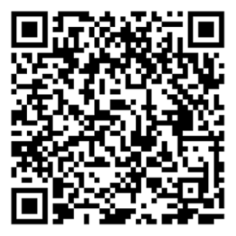
URL: https://www.etsu.edu/curriculum-innovation/syllabusattachment.php

Disclaimers

Syllabus Changes
The instructor reserves the right to make changes to this syllabus as necessary. If changes are necessitated during the course term, the instructor will immediately notify you by email and on the course site, posting both the notification and the nature of the change(s).

Schedule Changes
The instructor reserves the right to change the course schedule as necessary. If changes are necessitated during the course's term, the instructor will immediately notify you by posting both the notification and the nature of the change(s) on the course site.

Appendix

i. Course Offerings and D2L Sites
Using Information Technology is divided into lecture and lab sections. Please ensure that you have registered for both CSCI-1100-901 (lecture) and CSCI-1150-901 (lab).

Your D2L Lecture Site:
Your lecture site contains lecture resources, Quizzes and Exit Tickets.
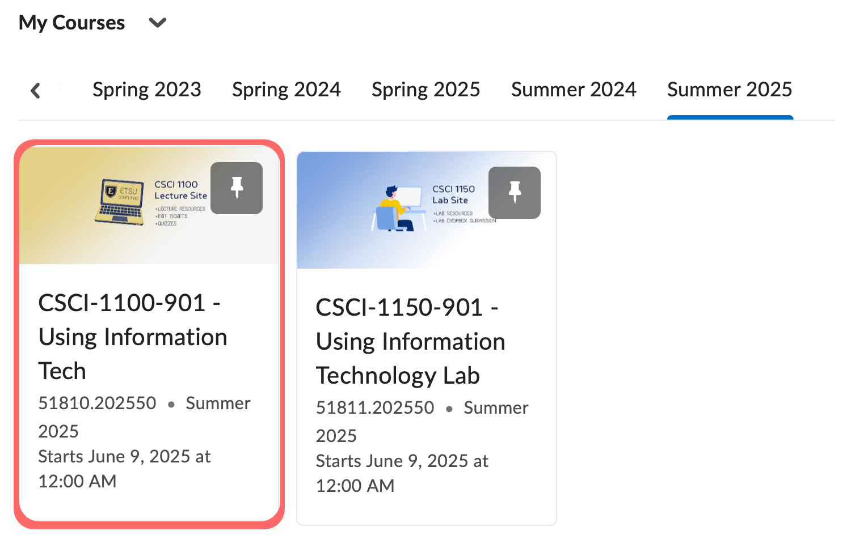

Your D2L Lab Site:
Your lab site contains lab resources and the Dropbox folders where you will submit your labs.
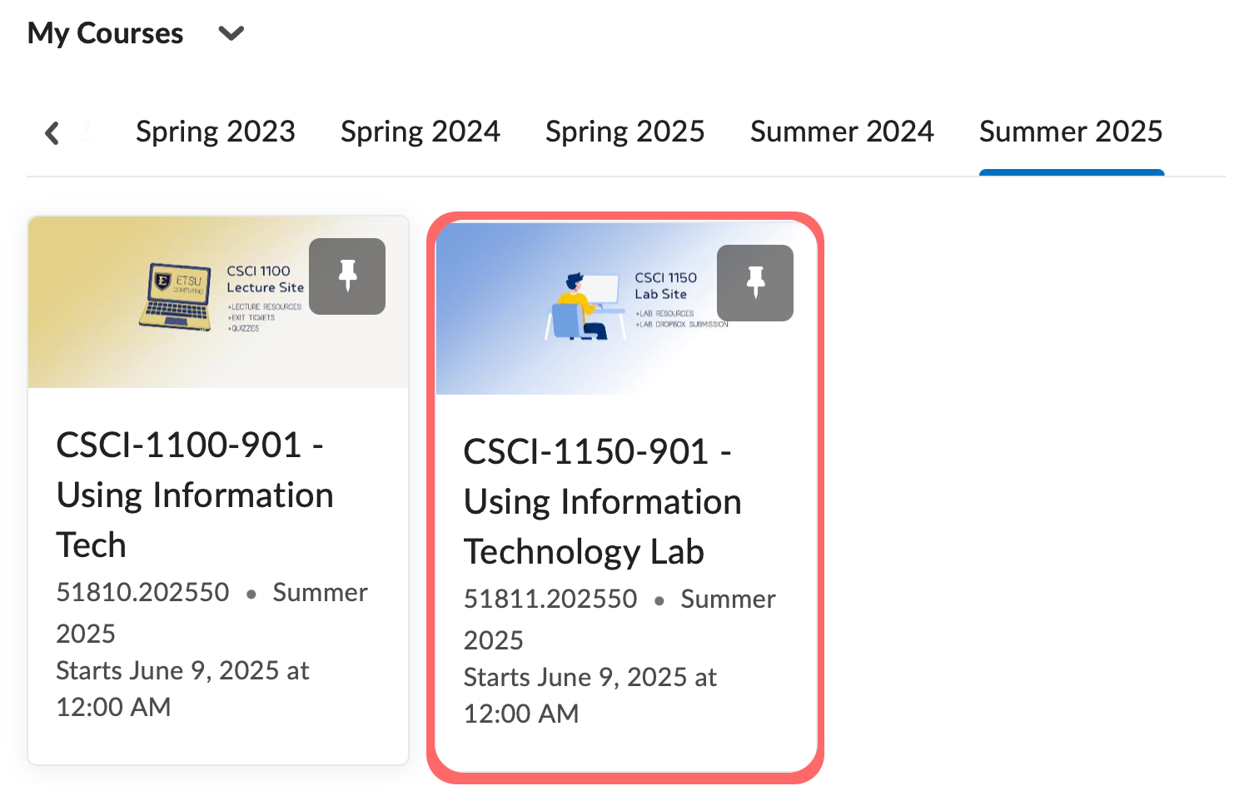

ii. Your Assignments Schedule (lecture and lab)
Section 901 Assignments Schedule (Summer 2025)

